# Questions

## 1.

|  |  |
| --- | --- |
| Pyplot Interface | Object-Oriented Interface |
| High-level interface inspired by MATLAB. | Low-level, more flexible approach. |
| Stateless - relies on global functions to create and modify plots. | Stateful - creates and manipulates plot elements through Python objects. |
| Less control over individual plot elements. | Provides fine-grained control over individual plot components (e.g., axes, figures). |
| Easier for simple, one-off plots and quick visualizations. | Ideal for creating complex, customized, and multi-panel plots. |

## 2.

The Seaborn library’s purpose is to simplify the creation of aesthetically pleasing and informative statistical plots.

**Example:**

* Seaborn’s distplot:

To visualize the distribution of univariate dataset.

* Seaborn’s heatmap:

To display matrix dataset as colored grid

## 3.

Scatter Plot:

**Benefits:**

1. Shows individual data points, making it suitable for visualizing distributions.

2. Effective for identifying outliers or patterns in the data.

**Drawbacks:**

1. Limited in conveying trends or patterns over time or a continuous range.

2. Does not show the overall shape or trajectory of data points.

**Scenarios:**

Can be used while exploring relationships between two continuous variables and identifying outliers in data.

Line Plot:

**Benefits:**

1. Displays trends/ patterns over a continuous range or time.

2. Effective for displaying sequential data or time series.

**Drawbacks:**

1. May obscure individual data points.

2. Less effective for visualizing the distribution of data.

**Scenarios:**

Can be used when visualizing data with an inherent order or progression and trends/ patterns over a continuous range.

# Tasks

## Task 1:1

The code snippet has been pasted below:

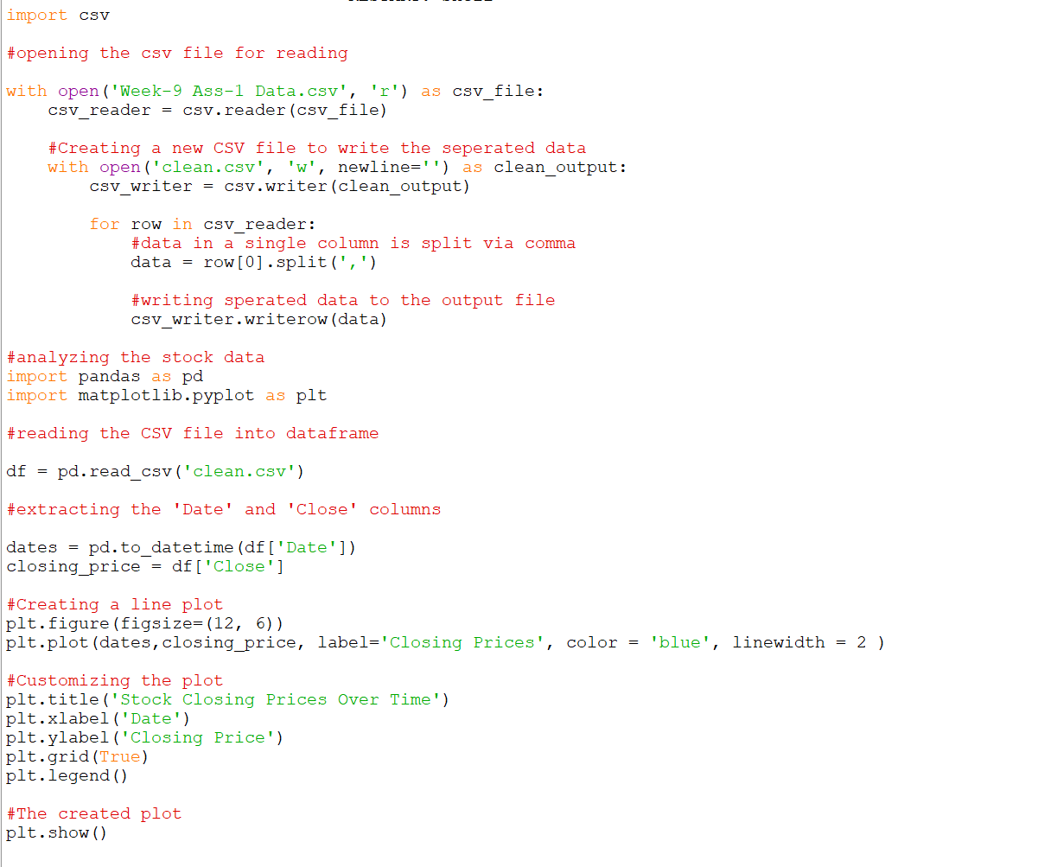

**The resulting line plot:**

## Task 2:

The code snippet has been pasted below:

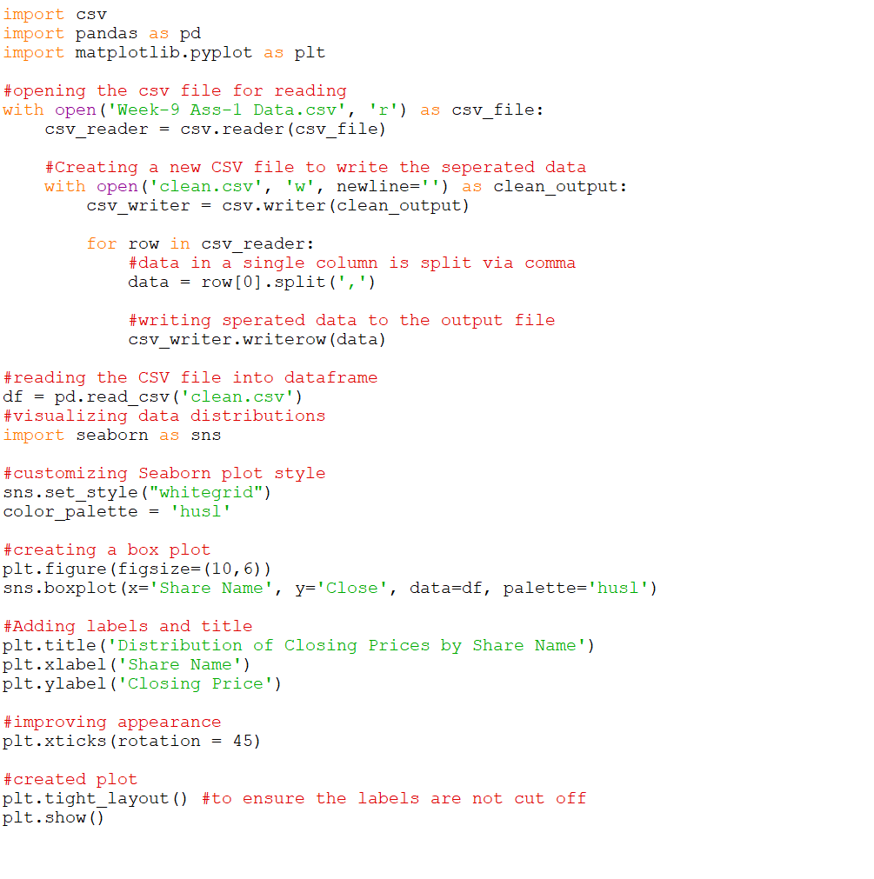

**The resulting box plot:**

## Task 3:

The code snippet has been pasted below:

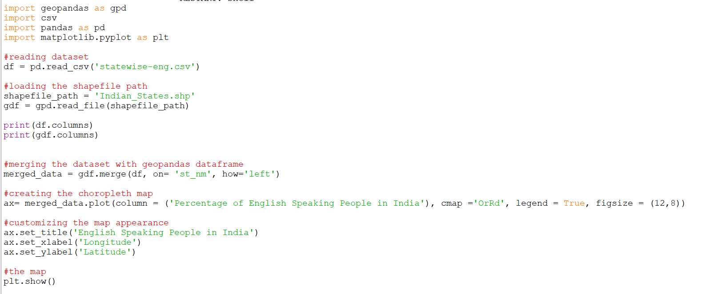

**The resulting choropleth map:**

